**Software Requirement Book**

**Prepared by:**

Vamsi Akula, Jasitha Boyapati, Deepthi Yanamala, Prachi Lotake & Jessy Jacob Mesapam

**Contents**

1. Data Report Charts functionality……………………….3
2. Landing Page functionality………………………...…...5
3. Horizontal CSV functionality…………………………..7
4. **Data Report Charts functionality**
   1. **Feature Description**

This feature aims to improve on the existing feature by providing the user the ability to add y-reference line (float value) and labels (of max char length 64) for each axis. This feature also gives user the option to generate scatter or line plots. In the current version, the user can generate a report, and has the option to select the Point name, Data type, Colour, Consolidated chart. Individuals can then view the chart by clicking the “View Charts” button once the report is generated.

* 1. **Assumptions**
     1. Assume the user is familiar with how report charts were being generated for each sensor as per current data report chart functionality.
     2. Assume the user is familiar with the nomenclature of the database to select their sensor of interest.
  2. **Glossary**
     1. Scatter Plot: A graph in which the values of two variables are plotted along two axes, the pattern of the resulting points revealing any correlation present.
     2. Reference line: to indicate a trend line for a set of data.
     3. Axes/Axis labels: describes data represented on entire axes.
     4. Point Name: Point Name in the dataset is the column which contains all the names of sensors. When referring to a point name we refer to a sensor.
     5. Input field: The section in a web page where users can input data or information is commonly referred to as an "input field" or an "input area."
  3. **Functional Requirements**
     1. There shall be an additional input field ‘chart type’ which is added next to the Consolidated chart.

1.4.1.1 This has two radio buttons – Line and Scatter, which allows the user to select which type of representation they want for the data from the sensor selected.

* + 1. An input field ‘Title’ shall be added next to ‘chart type’ which allows the user to add title with maximum character length of 64 to each chart generated in the report.
       1. The ‘Title’ input field shall take alphanumeric characters and underscore ‘_’ special character only as a valid input.
    2. There shall be two additional input fields such as X-axis Label and Y-axis Label.
       1. The inputs from these will be used as the labels with maximum character length of 32 for the charts to better understand and differentiate between different charts generated in the report.
       2. The character validation rule of ‘Title’ input field shall apply to axes label fields too.
       3. If the user tries to enter values more than 32 characters, the input field shall take the first 32 characters entered.
    3. There shall be an additional input field for the y-reference line next to ‘Y-axis label.’
       1. This input is taken to add a line of the user's choice to the chart generated.
       2. This field shall take float value as input.
       3. In the absence of this value, there shall be no reference line seen in the plot.
  1. **Behavioural Example**

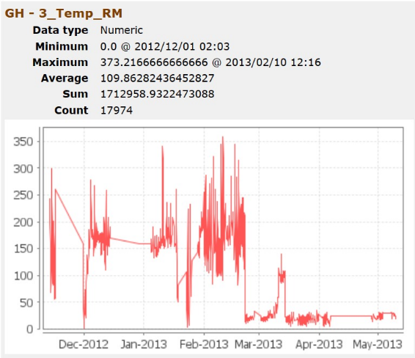 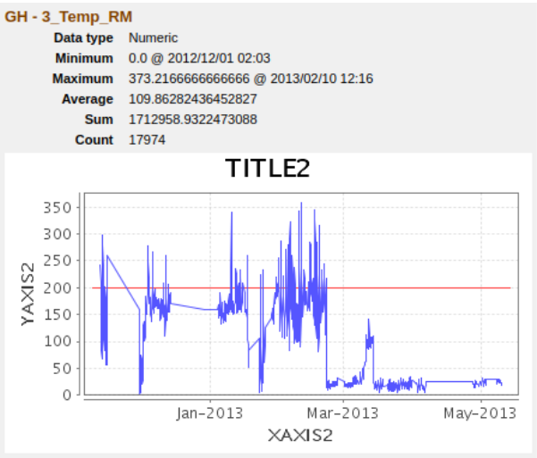

1(a) 1(b)

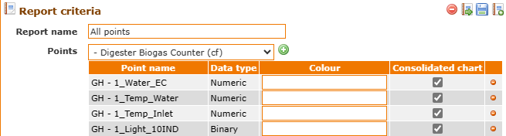

1(c)



1(d)

Fig.1: (a) chart prepared from GH-3_Temp_RM with current feature conditions;   
(b) chart prepared from GH-3_Temp_RM after the addition of new feature;  
(c) Current user interface for report generation; (d) User interface post new feature addition

1. **Landing Page functionality**
   1. **Feature Description**

This feature aims to create a customized landing page with a watchlist on the right half of webpage and a description of mango and the sensors used in the database on the left. The current version has the default landing page set to watchlist page and the user has an option to set or reset any page as the landing page with ‘Make this my default page’ button on the top-right of the navigation bar. A new ‘Landing Page’ button to reach the customized landing page is to be added to the navigation bar.

* 1. **Assumptions**
     1. Assume the user is familiar with navigation bar and using the different icons on it to move through different pages within Mango.
     2. Assume the user is familiar with the set and unset buttons to modify pages of their choice as default landing page.

* 1. **Glossary**
     1. Landing Page: A landing page is a standalone web page that serves as the entry point for the users who arrive on a website after logging in.
     2. Navigation bar: Navigation bar is a graphical user interface (GUI), appears at the top and contains a set of clickable links or buttons that allow users to navigate between different sections or pages within the site or application
     3. Watchlist: A list of things to be monitored, especially to prevent loss, damage, etc.
     4. Hyperlink: Hyperlinks can be presented in different forms, like an image, icon, text, or any type of visible element that, when clicked, redirects you to a specified URL.
  2. **Functional Requirements**
     1. There shall be a new default landing page when the users log in or access the Mango program.
        1. As a point of entry into Mango, the left half of the landing page provides basic details on the software, its functionalities, and the sensors that are part of its ecosystem.
           1. These basic details include a hyperlink to help page created at the bottom of the left tab with a message ‘To access our Help resources, please click on the “Help” link below.’ A descriptive diagram of the sensors included in the database such as GH_1_light, GH_2_RM_Temp, GH_3_Pump, GH-3_Sprayer etc, is also included in this tab.
        2. The landing page shall also include the watchlist interface on the right to allow the user to monitor sensor points of interest. The user has the flexibility to choose which sensors to include in this list. If the user has not set any sensors the recently used ones are selected by default in this page.
     2. The navigation bar should include a hyperlink icon at the left most corner with name as landing page. This icon gives users a visual clue to quickly access this landing page.
        1. The user will have the choice to set and unset this newly created page as their new homepage using the button on the right corner of the navigation bar.
  3. **Behavioural Example**

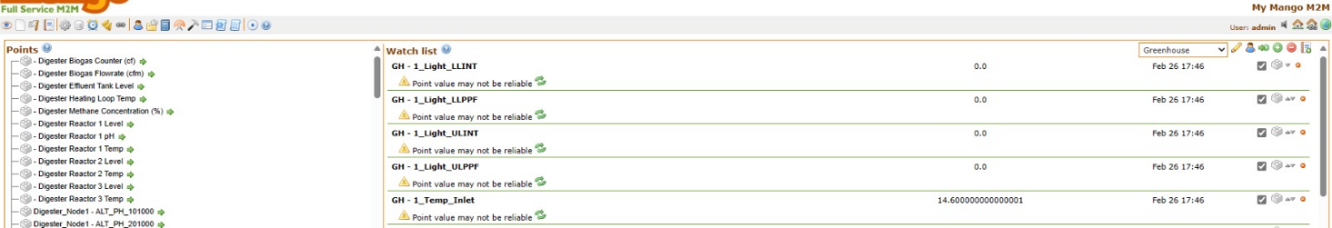

2(a)

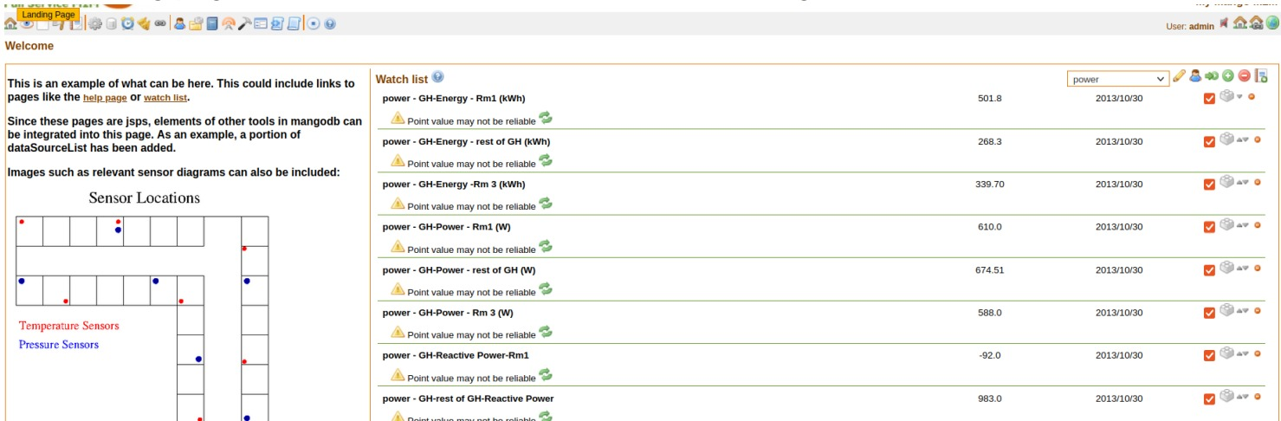

2(b)

Fig2: (a) Current default page(watchlist) shown after logging into the mango software;  
(b) Expected behaviour of the required landing page after the completion of all the additions specified.

1. **Horizontal CSV functionality**
   1. **Feature Description**

This feature aims to alter the way data is spread across a CSV file that is produced when exporting a report generated such that each sensor has its own set of output parameters. The current version shows the data of all the sensor under the same five columns, while the updated feature will have these 5 columns separately for each sensor and can be read easily in a horizontal format. while the data for each individual sensor will be read in vertical.

* 1. **Assumptions**
     1. Assume the user has the technical capabilities to interact with mango and generate custom reports.
     2. Assume the user understands the significance of different data fields like, point name, Value, Time, Rendered and annotation.
     3. Assume the user has the clear understandings of the format and contents they expect in the generated CSV reports and the process of generating, accessing, and reading the reports.
  2. **Glossary**
     1. CSV: It is a Comma Separated Value (CSV) file, a text containing data with each data point separated by the commas. A CSV file is used to move data between programs that are not able to change the data.
     2. Horizontal format: Representing the data in the CSV file such that within data point selected each sensor data is separate and are horizontally next to each other.
  3. **Functional Requirements**
     1. There shall be an addition of a new set of columns (“Point Name”, “Time”, “Value”, “Rendered”, “Annotation”) adjacent to the previous columns in the report with every new point name identified. This will result with the data entry being done in separate columns for each sensor.
        1. To view this CSV file the user must generate a report. A report can be generated by the user after selecting the point, point names and the data range of time of their choice under the report tab and clicking run. After the report is generated, the user can download the data file using the ‘Export Data’ button.
  4. **Behavioural Example**

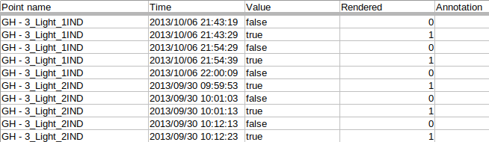

3(a)

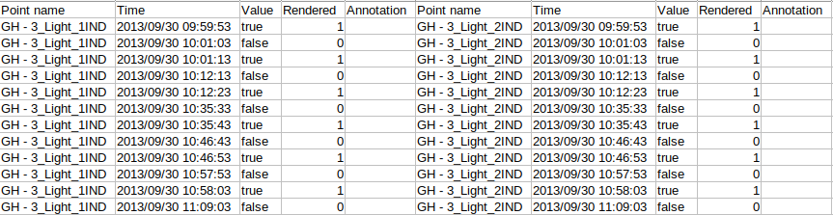

3(b)

Fig3: (a) Current CSV file format with all sensors under same point name column;   
(b) Expected CSV file format with sensors separated horizontally with respective columns.